FEDERATED STATES OF MICRONESIA



EXPRESS OF INTEREST (EOI)
for
Innovative Hydro Pilot Project in Pohnpei State
Supply, Installation and Operation

GRANT 6050 FSM: ADB Clean Energy Project
Project Readiness Financing (PRF)

Department of Resources Development (DoRD)
Palikir, Pohnpei FM 96941
Federated Sates of Micronesia.

14th November 2024-15th April 2025

DEPARTMENT OF RESOURCES & DEVELOPMENT

Federated States of Micronesia

P.O. Box PS-12

Palikir, Pohnpei FM 96941
Phone: (691) 320-2620/2646/5133

E-mail: fsmrd@fsmrd.fm

Express of Interest (EOI): EOI/CEP-PRF/HYD/1
Innovative Hydro Pilot Project- Pohnpei state
ADB Clean Energy Project- Project Readiness Financing (PRF)
Open: 14th November, 2024
Close: 15th April, 2025 at 5pm Pohnpei Time

- General Introduction
The Government of FSM has requested the Asian Development Bank (ADB) to finance the FSM's clean energy and water projects. Potential future investment projects will expand its population's access to modern energy and water services; improve service quality, reliability, and climate resilience; and reduce the FSM's reliance on fossil fuels for power generation, corresponding to reduced generation costs and GHG emissions.
Pohnpei in the Federated State of Micronesia is one of the few places where favorable geographical and hydrological conditions are existing to develop hydro power projects in FSM. Several hydro power projects were identified through desk studies and subsequent site visits which can be developed to generate and supply power to the utility or for off grid communities.

Project: The Division of Energy, Department of Resources and Development (DoRD), through the Clean Energy Project- Project Readiness Financing (PRF) hereby invite interested parties to submit Express of Interest (EOI) to supply, install & commission Innovative, off the shelf, modular and transformative hydro generator technologies and associated electrical switchgears in one or more of the three selected sites. These project/s is to be connected to the low voltage (240V AC L-L) line of the Pohnpei Utility Corporation (PUC), available in the vicinity of the selected sites. Applicant are allowed submit multiple Proposals incase if they are interested more than one sites.

- Eligibility
A company submitting Application for the EOI should be a duly registered entity that can enter into contract with the Government of the Federated States of Micronesia (FSM). The company should be able to design, supply, install, commission and operate this hydro project for given period specified in the Terms of Reference (TOR), Appendix 1 of this EOI. The applicant should satisfy the following conditions to apply for the EOI.
- The applicant should have a design and manufacturing facility or is an authorized distributor or an agent of a manufacture of hydro turbine and accessories. Applicant must attach documents such as authorization letter issued by the turbine/ accessory manufacture, catalogues, data sheets, list of references etc. as evidence.
- This EOI is for the provision of equipment and services with necessary supervision, backstopping, operation and training. It covers a total organizational responsibility as required by the Terms of Reference which is attached as Appendix 3 of this document.
Therefore, your application must include information in sufficient scope to allow DoRD to consider whether your company/ organization has the necessary capability, experience, knowledge, expertise, finance strength and the required capacity to perform the work specified satisfactorily. In order to be considered for the contract your company/ organization must meet the qualification requirements and evaluation criteria specified in Appendix 4 of this EOI.
- In addition, your ability to commence work and complete it strictly in accordance with General Time Schedule contained in the section 76 of the Terms of Reference, Appendix 3 will be an important factor in awarding a contract.
- If your firm, joint venture partners, associates, parent company, affiliates or subsidiaries, including any subcontractors or suppliers for any part of the Contract should be from a ADB member country ((https://www.adb.org/about/members), if not your Application shall not be considered for evaluation.
- The Applicant has to, during the application process as well as the implementation process, adhere to ADB’s Anticorruption Policy and Integrity Principles and Guidelines.
- A firm/individual, joint venture partners, associates, parent company, affiliates or subsidiaries, including any subcontractors or suppliers for any part of the Contract shall not be eligible to participate while under temporary suspension or debarment or declared ineligible, or blacklisted by ADB pursuant to its ADB’s Anticorruption Policy, whether such debarment was directly imposed by ADB, or enforced by ADB pursuant to the Agreement for Mutual Enforcement of Debarment Decisions.
- If the importation of goods or services from your country or any payment to persons or entities in your country is prohibited in compliance with a decision of the United Nations Security Council under Chapter VII of the Charter of the United Nations, you are not eligible to participate for this EOI.
- Under ADB’s Anticorruption Policy (1998, as amended to date), Applicants shall observe the highest standard of ethics during the procurement and execution of such contracts. ADB may reject an Application for award, and may impose sanctions or other remedial actions on parties involved, if it determines that the Applicant recommended for award or any other party, directly or through an agent, has engaged in corrupt, fraudulent, collusive, coercive, or obstructive practices or other integrity violations in competing for, or in executing, the Contract.
- Any misrepresentation that knowingly or recklessly misleads, or attempts to mislead may lead to the automatic rejection of the Application or cancellation of the Contract, if awarded, and may result in remedial actions, in accordance with ADB’s Anticorruption Policy (1998, as amended to date) and Integrity Principles and Guidelines. (2015 as amended from time to time).
- An Applicant shall not have a conflict of interest. All Applicants found to have a conflict of interest shall be disqualified.

- Closing Date
To ensure consideration, your completed application should reach the address indicated in Section 9 of the INSTRUCTIONS FOR THE PREPARATIONA AND SUBMISSION OF APPLICATION FOR EOI by 15th April 2025, close of business 5 pm Pohnpei time (GMT+11) during working hours of the DoRD, Monday to Friday 9am to 5pm, except National and State holidays. EOI received after the above-mentioned deadline will be invalidated.
We looking forward to receiving your proposal.
Sincerely,

Secretary - Department of Resources and Development (DoRD)

Enclosures
Appendix 1: INSTRUCTIONS FOR THE PREPARATIONA AND SUBMISSION OF APPLICATION FOR THE EOI
Appendix 2: STATEMENT OF CONFIRMATION
Appendix 3: Terms of Reference
Appendix 4: Qualification Requirement and Evaluation Criteria

Appendix 1
INSTRUCTIONS FOR THE PREPARATIONA AND SUBMISSION OF APPLICATION FOR THE EOI
- Content of the Application for the EOI
Hydro pilots that are aimed to be implemented under PRF needs to be innovative technologies which can be deployed quickly and with less safeguard impact and also can be expanded based on the necessity (modular units).
Application for EOI should have two parts as Technical and Commercial Parts should contain, but not necessarily be limited to, the following information:
  - TECHNICAL PART OF APPLICATION in the form of Pre-Feasibility Report
- Certified copy of the Business registration, Financial Statement for the past three years of business and information regarding all claims, arbitrations and other pending legal action concerning main Applicant’s company and JV partners, if exits.
- Any Joint Venture Agreement (JVA) related to this EOI with another company either in FSM or any other country. This agreement should describe the scope of work, each party will perform and how the overall responsibility will be taken care.
- A statement of your company/ organization’s ability and readiness to execute an eventual contract in accordance with this EOI. Any deviation from the Terms of Reference (Appendix 3) or other documents contained in this EOI shall be clearly expressed.
- A statement of your company or JV partner has been authorized as an agent or distributor for the proposed innovative hydro turbine technology. If not, provide proof that the innovative technology supplier has given consent to use this technology, with you, in the proposed EOI sites.
- An introduction of the company, its main businesses; information of presence in the pacific regional, if applicable and product and services it offered especially related to the EOI.
- Test certification preferably done by third party institution on the performance of the Innovative Electro mechanical equipment proposed to the EOI.
- Case study reports or Testing commissioning reports or kind of performance report, preferably from third party organization about projects where proposed equipment has been installed. Highlighting the challenges faces, if any, in implementing similar project elsewhere would also encourage to provide which will help in minimizing risk.
- Provide reference with contact information about past experience of your organization or consortium on establishing mini/ micro hydropower sites below 1 MW range. Evidence in the form of case studies, with references (client information with contact details), should be provided on the successful implementation of the innovative hydro technologies that the Applicant if proposing for the EOI.
- The names, titles and proposed functions and brief description of their qualification and experience of the key staff assigned for this contract. Names and qualifications of the proposed sub-contractors, and/or equipment manufacturers, if any, and the extent and nature of sub-contracting and/or equipment supply would be necessary.
- Provide company’s guidelines on Environmental and Social Code of Practices (ESCP), Health and Safety Guidelines for Staff which is applicable to the project in the EOI. On the proposed technology, Applicant has to update and provide mitigatory measures, if applicable on the Environmental and Social Screening reports done on the selected site/s which was shared in the section 5 of Terms of Reference in Appendix 3 of the EOI.
- Evidence of working capital requirement in order to assure smooth cash flow to ensure uninterrupted implementation of the Project/s.
- Signed Statement of Confirmation in the format given in the EOI in Appendix 2, without alteration.
- A Pre-Feasibility level report of the Proposed Innovative hydro Solution to the selected site/s with minimum information as stated in the Terms of Reference (TOR) in the Appendix 3 of this EOI. (Detailed Feasibility report is only required for shortlisted Applicants at later stage.)
- Any other information you may consider appropriate. The Applicant may be requested at any stage to provide additional information and/or documentation to support their application.
1.2 COMMERCIAL PROPOSAL (to be submitted in the same envelope)
Commercial Proposal should contain, but not necessarily be limited to, the following information.
- Your best fixed price in US dollars to complete the proposed scope of work described in the Terms of Reference in Appendix 3 of EOI. Please note that prices for equipment, parts and supplies shall be quoted DDU (INCOTERMS 2000) Plant Site.
- A detailed cost breakdown as a Bill of Quantities (BOQ) for the cost foreseen to perform as different activities; divided as main categories. (e.g. of possible categories are personnel, travel and local cost, design and engineering, equipment, material, spare parts, transportation, insurance during transporting & construction, construction and erection, commissioning, operating of the plant for one month period, on the job training during installation & during one month of operation period etc.)
- Your cash flow estimate related to the execution of the scope of work with highlighting the project millstones for which payment is expected to request.
- A statement that your Application is valid for minimum period of six (6) months counting form the date of the EOI. Once your Application is accepted during this period, the price quoted in your Application must remain unchanged for entire period.
All documents for EOI should be submitted in English language.
The shortlisting and final selection of prospective Applicant will be done on final marks with weightage of 70:30 on the Technical and Commercial proposals respectively.
- Cost of preparation and submission Application
The prospective EOI Applicant including the shortlisted Applicants shall bear all costs associated with the preparation and submission of Application for the EOI. The DoRD shall not be liable for costs incurred up to the final approval of the Innovative hydro project being proposed. Following submission of the Application and final evaluation, DoRD will have the right to retain unsuccessful proposals. It is the Proponent’s responsibility to identify any information of a confidential or proprietary nature contained in its Application, so that it may be handled accordingly.
- Shortlisting Applicants
Following evaluation of the EOIs, DoRD will select maximum number of three (3) Applicants, based on the ranking in the evaluation to provide a detailed Feasibility report for the site/s selected. Content of the detailed Feasibility is stated in the Terms of Reference (TOR) in the Appendix 3 of this EOI.
- Evaluation Procedure & Acceptance of Application
All Applications that are submitted in response to this EOI & subsequent detailed Feasibility reports received from the shortlisted applicants will be reviewed and evaluated by DoRD in fair and impartial way in accordance with the provisions of the ADB Procurement Policy| of Asian Development Bank.
The Applications for the EOI & detailed feasibility reports from shortlisted applicants will be evaluated based on the following criteria: (a) novelty/innovativeness (b) ease of installation and operation (c) level of impact to the environment and surrounded community (d) evidence of site and/or performance testing & (e) scalability. More information on the Qualification requirement and Evaluation criteria are stated in Appendix 4 of this EOI. Please note while price is an important factor, however, it shall not be the primary consideration in evaluating responses to this EOI.
- Period of Contract Service, Work Plan and Bar Chart
The overall period for the completion of the work is indicated in the section 7 of the Terms of Reference in Appendix 3 of the EOI. Your Application must include a time schedule for completion of the scope of work of the Application as a bar chart with identification of major millstones related to proposed payment plan.
- Multiple Applications
Separate Application is need in case if the Applicant is wish to Apply for more than one site.
- Type of Contract
A firm, fixed price is contemplated for the contract/s, covering all the inputs required of the Contractor as sated in the Terms of Reference, Appendix 3 of the EOI. Please note the budget for the proposed EOI will be approximately USD 300,000 and these figures are for your information only and should not influence your professional assessment of the actual project requirements and work input necessary to meet all project objectives.
- Format and Signing of EOI Application
Your Application should be submitted in accordance with the following instructions, procedures, and the terms and conditions.
- Your Application shall be submitted in ONE SEALED ENVELOP, which shall contain the Technical Proposal & Commercial Proposal with price(s) and commercial terms. Application must be submitted in one (1) original and two (2) copies each, clearly marked “Original Proposal” and “Copy Proposal”. In the event any discrepancy between them, the Original shall govern.
- Your Application must be typed or written in English language in indelible ink and signed by an official authorized to enter into Contract on behalf of your company or consortium.
- Marking of the sealed envelope should be done as below.
Express of Interest: CEP-PRF/HYD/1- Innovative Hydro Pilot Project APPLICATION
Site Name: [site name is available Appendix 3 the Terms of Reference]
Closing Date: 15th April, 2025
Do not open before the Closing Date
- Submission of Application for EOI
Your Application must be submitted to the following address by 5:00 pm Pohnpei time (GMT +11) on 15th April, 2025
DoRD’s Address: Department of Resources and Development (DoRD),
FSM National Government
P.O. Box PS-12
Palikir, Pohnpei 96941
Email: fsmrd@rd.gov.fm
Telephone: 691 320 2646/5133

[Or]
Your Application may be submitted electronically by email (password to be send as separate email) to the following address:
DoRD’s Address: Department of Resources and Development (DoRD),
FSM National Government
P.O. Box PS-12
Palikir, Pohnpei 96941
Telephone: 691 320 2646/5133
E-mail: fsmrd@rd.gov.fm

Cc: Clean Energy Coordinator
E-mail: stephen.yarofalig@rd.gov.fm

Subject of the email: Innovative Hydro Pilot EOI Application- Energy & Water division
- Further information and clarification can be obtained from:
Name: Mr. Faustino Yarofaisug, Assistant Secretary
Address: Department of Resources and Development (DoRD),
FSM National Government, Palikir, Pohnpei
Telephone: 691 320 2646/5133
E-mail: fyarofaisug@rd.gov.fm and stephen.yarofalig@rd.gov.fm

- Contract Award & Signing of Contract
After detailed Feasibility reports evaluation from the shortlisted Applicants, DoRD will notify the successful Applicant, in writing, that their Application has been accepted for implementation. DoRD will send the Contract document incorporating all agreements between parties to the successful Applicant for to sign and date the contract and return it to DoRD within two (2) calendar weeks of the receipt of the contract document.
Upon the successful Applicants’ acceptance of the Contract award and Conclusion of the contract, DoRD will notify each unsuccessful shortlisted Applicants.
- Payment
The normal terms of payment by DoRD for ADB funded projects of this nature is Progress payment on agreed milestones. Applicants must clearly specify their anticipated payment plan and corresponding milestone in their Application and in subsequent detailed Feasibility reports.
- Registration of Applicants
Parties interested to Apply for this EOI and/or obtain further updates, if available, may fill the google form given in the following link.
https://forms.gle/WMAQFjDkzFRmGrCA8

Appendix 2
STATEMENT OF CONFIRMATION
On behalf of (insert of company or institution) ……………………………….…………., I, hereby attest and confirmed that company/ organization:
- Possesses the legal status and capacity to enter inti legally binding contract with DoRD/ ADB for the supply of equipment, supplies, services or work.
- Is not insolvent, in receivership, bankrupt or being wound up, and not under administration by a Court or Judicial Officer, and that it is not subject to the suspension of its business or legal proceedings for any of the foregoing reasons.
- Has fulfilled all its obligations to pay taxes and social security contributions.
- Has not, and that its Directors and Officers have not, within the last five years been convicted of any criminal offence related to professional conduct or the making of false statement or misrepresentation as to their capacity or qualification to enter into procumbent or supply contract.
- Pursues zero tolerance policy to all forms of corruption, including extortion and bribery.
- That DoRD/ADB, in the event that any of the foregoing should occur at a later time, will be duly informed thereof, and in any event, will have the right to disqualify the company/institution form any further participation in its procurement proceedings.
- That DoRD/ADB shall have the right to disqualify the company/ institution from participation in any further procurement proceedings, if it offers, gives or agrees to give, directly or indirectly, to any current or former staff member of DoRD/ ADB a gratuity in any form, an offer of employment or any other of service or value, as an inducement with respect to an act or a decision of, or a procedure followed by DoRD/ ADB in connection with a procurement proceeding.

Name: Signature:
Tile/ Position:
Place (City and Country)
Date:

Appendix 3
Terms of Reference- Innovative Hydro Power Project- Pohnpei State
Express of Interest (EOI): EOI/CEP-PRF/HYD/1

1) GENERAL BACKGROUND INFROMATION:
The CEP PRF is the beginning of a second phase of ADB’s renewable energy grant financing program in FSM, following on the initial phase of the REDP focusing primarily on Chuuk and Pohnpei, with $5 million grant that will support initial feasibility studies for hydro power in Pohnpei and access to clean water using RE in Chuuk. The PRF will also fund small-scale pilot projects in both states. The outcome of the PRF is to clearly define what capital investments should be made in Pohnpei and Chuuk and where to place those investments that will expand both renewable energy and access to clean water for the citizens and residents of both states.

2) EXPRESS OF INTEREST (EOI):
The PRF will support small-scale pilot testing of innovative clean energy technologies including off the shelf scalable micro hydro solutions to demonstrate climate resilient and low safeguard intensive projects while identifying other renewable energy-based solutions to be taken up for pilots subsequently. Pilot activities will purchase and install innovative turbine generator units to test modern technology options to deliver clean energy for the ensuing project. There will be minimum or no land acquisition, social and environmental impacts are assessed to be minimal, site specific, and temporary. The pilots would be reviewed for scale-up and study including reports would be disseminated to representatives of the FSM states as well as other Pacific islands

The Division of Energy, Department of Resources and Development (DoRD), through the Clean Energy Project- Project Readiness Financing (PRF) hereby calls EOI from interested parties to supply, install & commission Innovative, off the shelf, modular and transformative hydro generator turbine unit, associated electrical switchgears and modal civil drawings that is required to installed the unit. Aim of this project is to connect to the low voltage (240V AC L-L) line of the Pohnpei Utility Corporation (PUC) available in the vicinity of site locations. Applicant are allowed submit Applications for more than one site, with separate Application incase if they are interested in multiple sites.

3) SITE DETAILS

Identified pilot hydro sites
Pohnpei in the Federated State of Micronesia is one of the few places where favorable geographical and hydrological conditions are present to develop hydro power projects. Asian Development Bank (ADB) funded Clean Energy Project -Project Readiness Facility (CEP-PRF) has identified potential small hydro sites, near the main road where the main grid is located, to develop grid connected hydro pilot project.

Three potential sites shown in the Figure 1 below were identified through USCG contour maps (with 10m contour intervals) and preliminary site visits.

Figure 1: Locations of small hydro sites
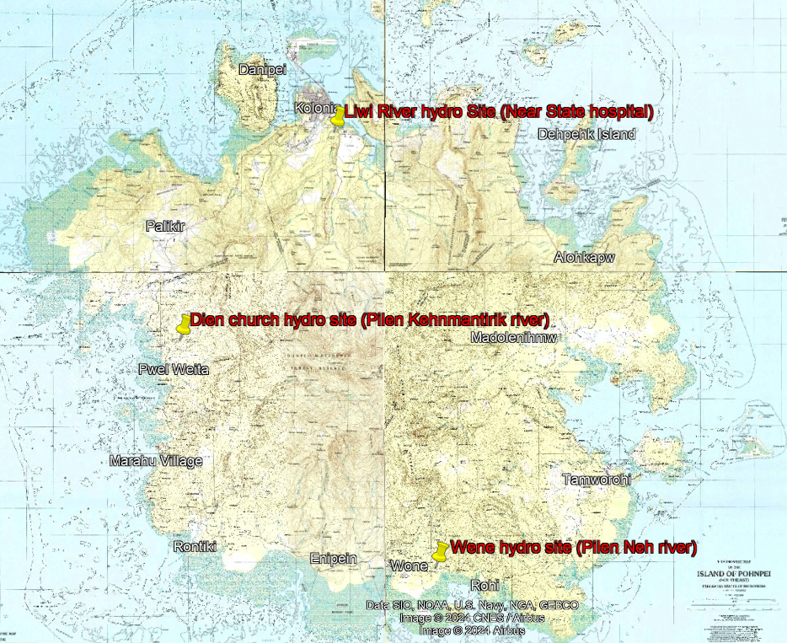
Table 1: Site Locations
No | Site Name | Latitude | Longitude | Maximum capacity (kW)
1 | Dien church hydro site (Pilen Kehnmantirik river) | 6°53' 7.95"N | 158° 9' 53.00"E | 100
2 | Wene hydro site (Pilen Neh river) | 6°48'35.16"N | 158°15'1.51"E | 100
3 | Liwi River hydro Site (Near State hospital) | 6°57'17.56"N | 158°12'58.86"E | 100

Site details
Transmission and distribution lines are located along the main road around the island and along few sub roads. Link to PUC power generation plant and distribution line: PUC distribution line map
So, the sites selected are close to the main road and/or closer to the sub road where the transmission and distribution lines are available enabling easy connection to the national grid. Details of three potential sites identified to develop pilot project are described below.
- Dien Church site (Pilen Kehnmantirik river)
This site is located 15 km from the Kolonia toward Kitti municipality. Road toward the left shown as a thin red line is the access road to the site. Proposed site is located about 200m from the Dien church.
Figure 2: Dien Church site (Pilen Kehnmantirik river) locations
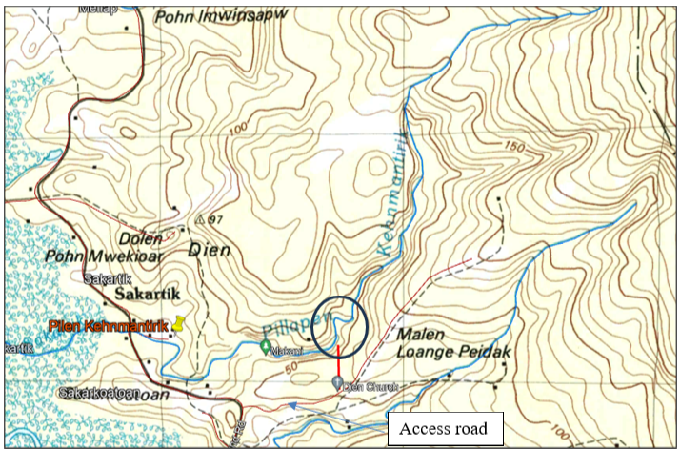
Dien church Site details (Pilen Kehnmantirik river):
- Access road is a gravel road which is motorable up to Dien Church and foot path is available to the river just by the Church and the distance is approximately 200 meters.
- Dilen Church is the last consumer with electricity connection from the Pohnpei Utility Corporation. Supply to the Church is a 1 phase 120V (L-N).
- PUC will extend the power line to the proposed power plant location (which is shown in a circle) which is about 200m from the Dien Church.
- Head (geographical elevation) available in the site is over 150m river stretch is 10m and Figure 3 below this elaborate more.
Figure 3: Dien church site (Pilen Kehnmantirik river)
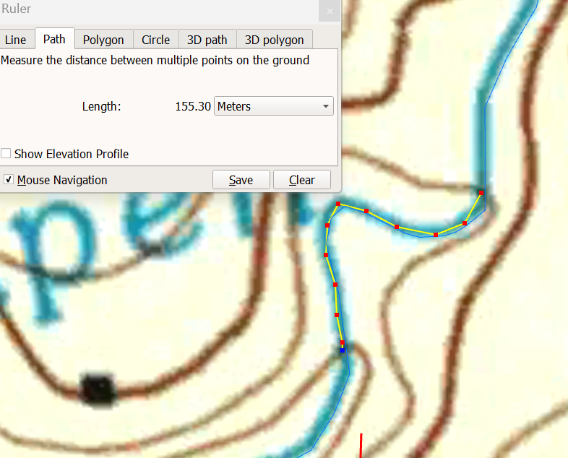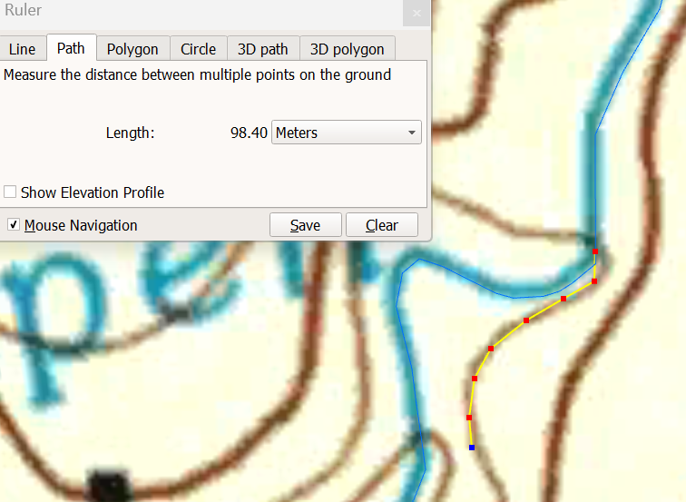

Photos and videos of the Dien church site (Pilen Kehnmantirik river)
Photos taken upstream location (about 300m upstream of proposed site) where tapping of water for community water supply system is happening is show below.
Figure 4: Pilen Kehnmantirik river (about 300m upstream): taken in March 2024
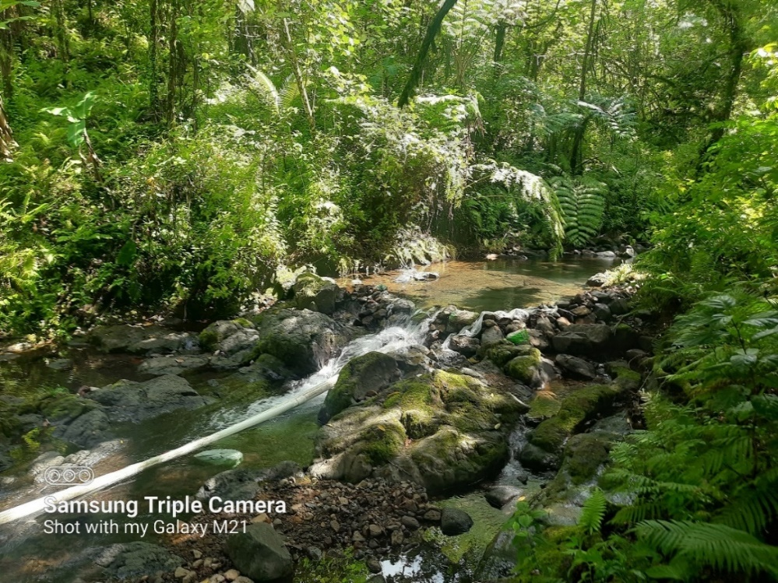
More photos and videos can be viewed from the link: Dien pilot site phots and videos

Flow duration curve of the Pilen Kehnmantirik river at proposed site
Flow duration curve of the site (with catchment area is 5.2 km² as shown in Figure 5) is show below. Daily rainfall data of FSM coastal best can be downloaded from the link: Dien pilot site rainfall and flow duration curve

Figure 5: Pilen Kehnmantirik river catchment area at proposed site
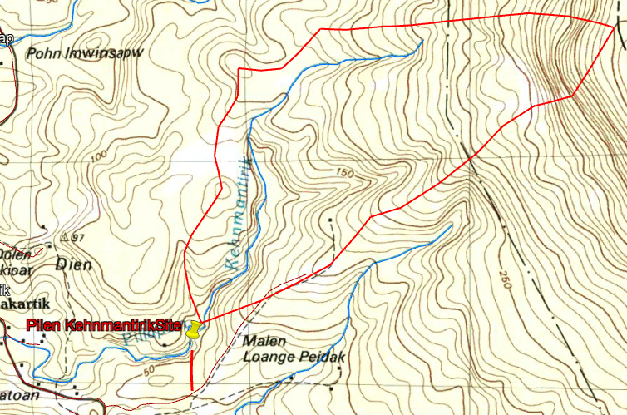

Figure 6: Flow duration curve of the Pilen Kehnmantirik river at proposed site
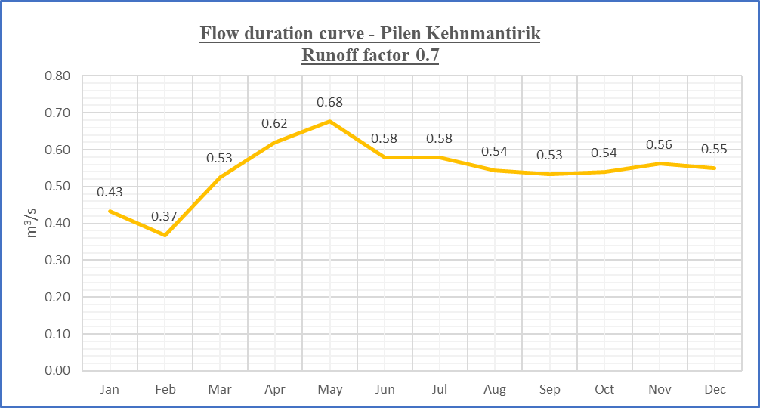

- Wene hydro site (Pilen Neh river)
This site is located in Wene village about 35 km from the Kolonia toward Kitti municipality. Site is located by the road and remaining (abutment) of an old bridge is available just few feet upstream of the existing bridge.
Figure 7: Wene site (Pilen Neh river)
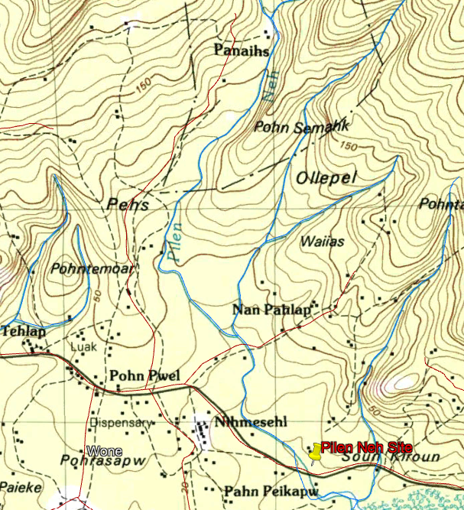

- Medium voltage (13.8kV/60Hz) and Low voltage (120V N-L/ 240 L-L/60 Hz) electricity line of the Pohnpei Utility Corporation is available along the main road which is less than 50m to the proposed site.
- PUC will extend the power line to the proposed power plant location.
- Proposed project can be designed using the existing abutment of the old bride and natural gradient available at site but this is not compulsory and project proponents can have their own designs and layouts.

Photos and videos of the site
Figure 8: Wene site (Pilen Neh river) photos (Taken on Mach 2024)
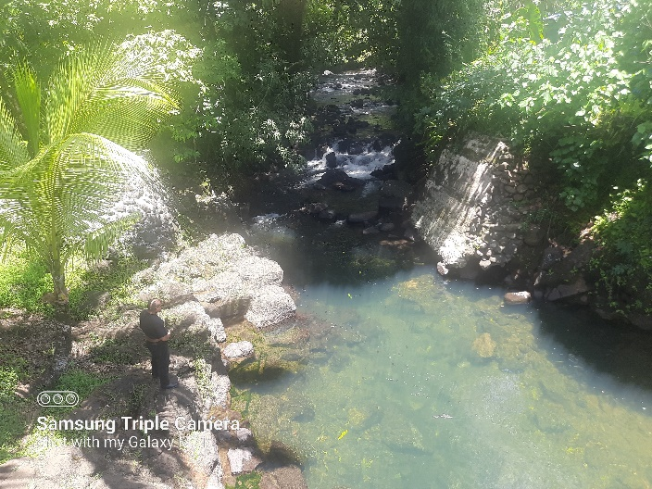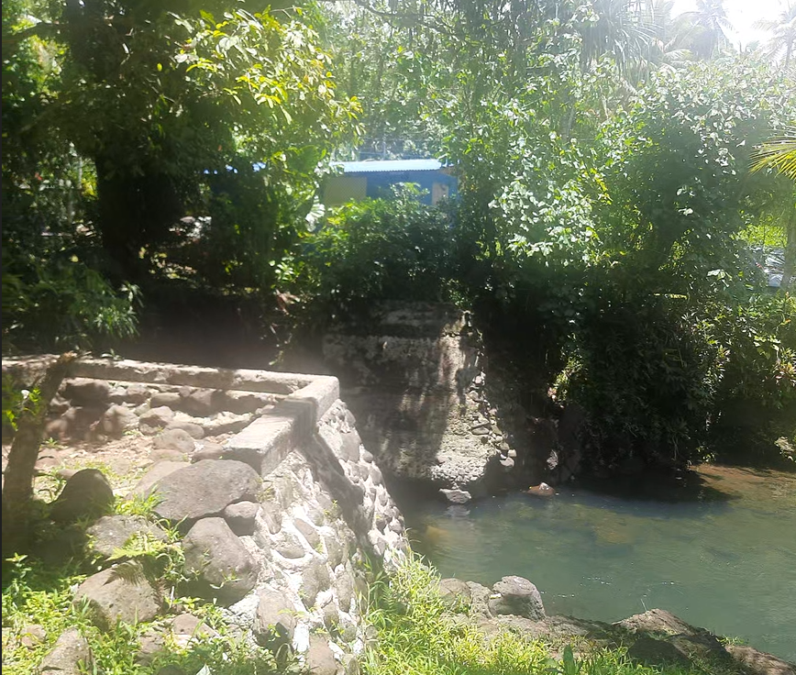
Photos and Videos can be viewed from the link below: Wene Pilot Sites Photos and Videos

Flow duration curve of the Wene river at proposed site
Flow duration curve of the site (with catchment area is 11.6 km² as in Figure 9) is show below. Daily rainfall data of FSM coastal best can be downloaded from the link:
Wene Pilot site rainfall and flow duration curve

Figure 9: Catchment area of Wene site (Pilen Neh river)
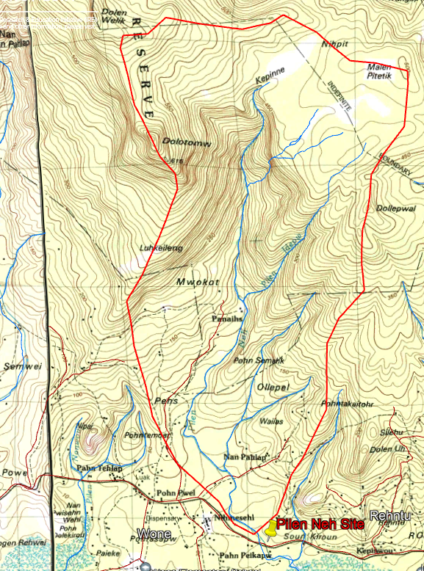

Figure 10: Flow duration curve of the Pilen Neh river at proposed site
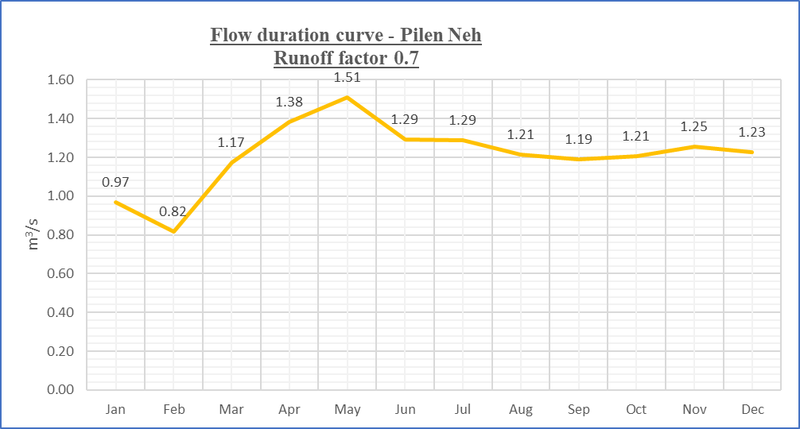
C) Liwi River hydro Site
One hydro site which was used by the Japanese during their stay in Pohnpei is located near the State Hospital/ Guam Bank has been identified as a potential location for such an innovative hydro project pilot testing.
Transmission and distribution line is available along the main road about 50m from the site location.

Figure 11: Liwi river hydro site (near Pohnpei state hospital)
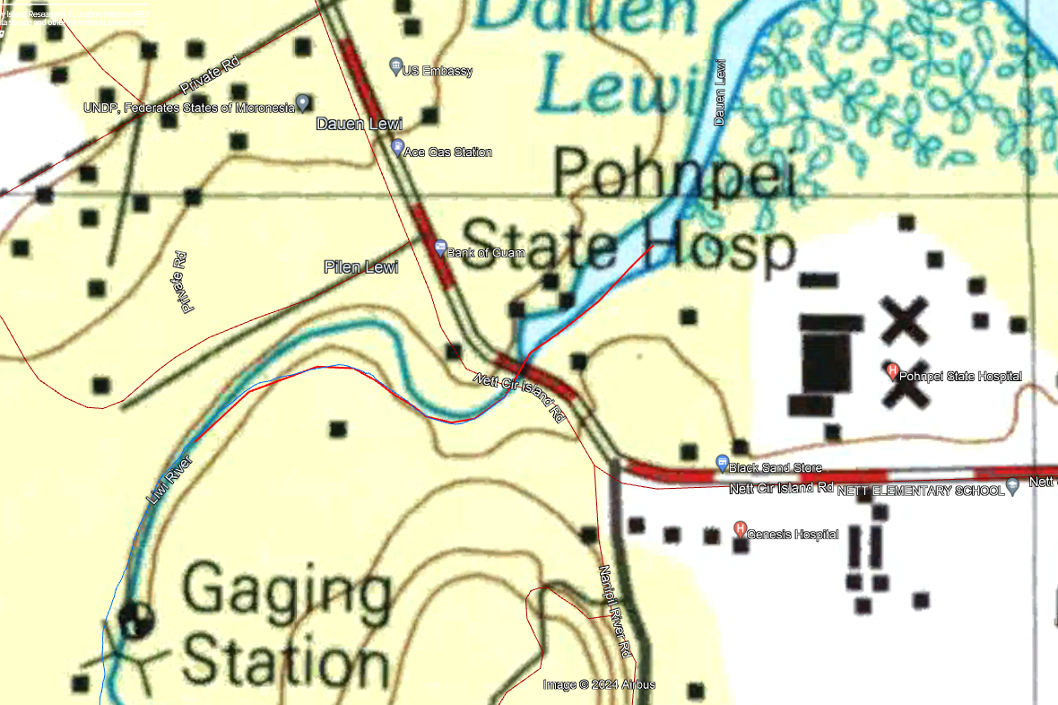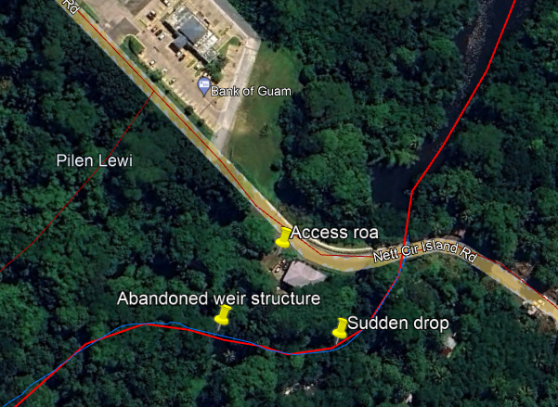
- Medium voltage (13.8kV/60Hz) and Low voltage (120V N-L/ 240 L-L/60 Hz) electricity line of the Pohnpei Utility Corporation is available along the main road which is less than 50m to the proposed site.
- Site location is privately owned and DoRD/ PUC will obtain the clearance to implement the project.
- No structure from the old Japanese hydro plant is available to see or use.
Photos and Videos can be viewed from the link: Liwi Pilot Site photos and videos
Flow duration curve
Flow duration curve of the site selected (with Catchment area of 9.8 km² as in Figure 13) is derived using daily rainfall data of the Pohnpei state is shown in Figure 12 and daily rainfall data can be downloaded from the link. Liwi Pilot site rainfall and flow duration curve

Figure 12: Flow duration curve of the Liwi River hydro site
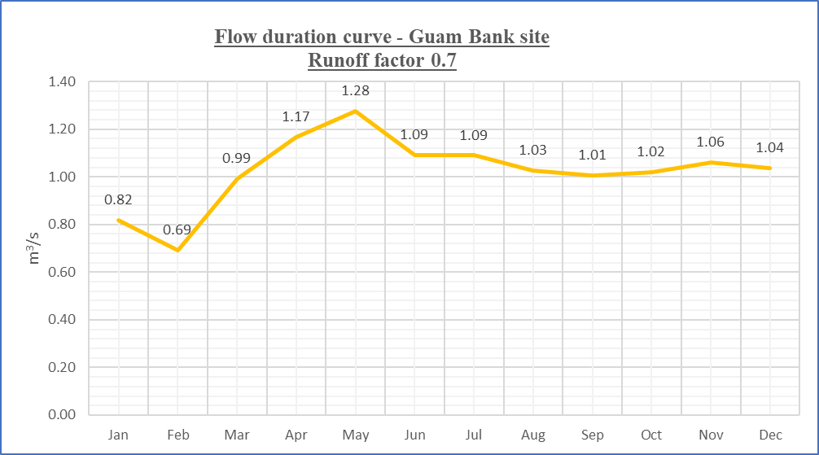
Figure 13: Catchment area of Liwi river site
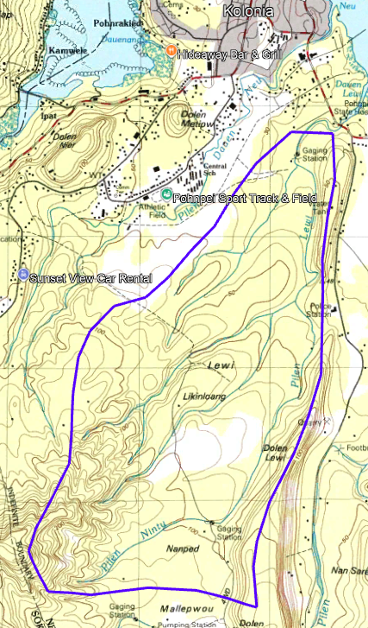

4) ENVIRONEMENTAL AND SOCIAL SCREENING REPORTS
Initial environmental and social screening reports done on the three sites is available from the link: Environmental and Social screening for the 3 pilot sites

5. SCOPE OF WORK OF EACH PARTY
In development of innovative hydro pilot, the applicant selected through EOI expected to do following scope of work as per the timeline agreed in the Contract stage.
5.1) Scope of work of the selected Contractor
- Provide the designs (electro mechanical and civil) and construction drawings of the proposed Innovative hydro technology with the final implementation plan for the prior approval of the DoRD/ADB.
- Construct weir & intake and the water conveyance system (pipe or channel or any other type) as per the approved design plans.
- Supply, Install and commission all the electro mechanical components including hydro turbine, alternator, governor and associated electrical accessories and grid interconnection panel.
- Installation, test and commissioning with PUC engineers and provide engineer’s test report to PUC and DoRD with a request for grid interconnection.
- Supply the spares required for 1 year period for all the Electro mechanical components supplied.
- Operate the grid connected plant for one month period while training the PUC engineers on O&M aspects and handover the project to the PUC.
- Provide 12 months warranty period from the date of successful interconnection to the PUC grid for (a) innovative hydro turbine, alternator unit with speed alteration unit, if exits (b) control panel and interconnection panel & (c) for civil structures including all water conveying components.
- Provide O&M manual for the innovative hydro project.

5.2) Scope of work of the DoRD/ PUC
- Provide land required for the project and land for temporary storage of civil construction material. Cost associated in obtaining land for the project will be paid by the DoRD/PUC while cost of renting of the land required to temporary storage of civil material needs to be paid by the Applicant. (Warehouse facility for storing of Electro/ mechanical equipment, if required and lodging facility for supplier’s crew is excluded here and should be arranged by the Applicant.)
- Liaise with local communities and help the selected Applicant in implementing the project. Help in resolving unexpected issues during the project construction period.
- Obtain the required statutory approval and permits and licenses including the environmental approval for development of the project. In obtaining these statutory approvals, the selected Applicant must provide requested technical documents and/or reports when requested.
- Helping the Applicant on the clearance of imported Electro Mechanical items duty free. Tax is needed to be paid by the Applicant.
- Review and approve detailed designs, construction drawings, monthly report and final project testing and commissioning report.
- Help the Contractor in commissioning the project together with the Applicant’s equipment suppliers of the Applicant’s and provide final approval for grid connection.
- Nominate operators and maintenance team members for the training and takeover the plant after successful operation of one month by the Applicant.

6 CONTENET OF TECHNICAL REPORTS
Content of Technical proposal of the application is described in the Section 1 of the INSTRUCTIONS FOR THE PREPARATIONA AND SUBMISSION OF APPLICATION FOR THE EOI in Annex 1 and this section elaborate only on the scope of the Pre-feasibility report which is a part of the Technical proposal.
6.1 Pre-Feasibility report
Content of the Pre-feasibility report and content of this Pre-feasibility report is elaborated more in this section, but not necessarily be limited the listed scope.
- Technical design: Based on the proposed site details provide section 3 of the Terms of References of this document, Applicants should provide Pre-Feasibility level technical report of their proposed innovative hydro technology that includes, but not necessarily limit to, the following information.
  - Outline the Technical Concept and/or innovative hydro modal the Applicant will propose for the proposed site/s in response to the EOI.
  - Technical calculation of the power output (specifications of all electro mechanical components) and its seasonal variation based on the Flow Duration Curve (FDC) and/or daily rainfall provided from 2000 to 2023 and efficiency of the hydro turbine unit and combine hydro turbine-generator- and speed drive units if applicable. Provide the Average monthly Energy calculation for a typical year and the anticipated plant factor.
  - Technical specifications of proposed innovative hydro plant including the electrical single line diagram (SLD), energy flow chart highlighting efficiencies/ losses with catalogues & datasheets of main components.
  - Drawings: Layout drawing of the proposed plant; Modal Drawings of the Turbine, speed increase/ reduction unit, Governor unit and min valve and/or other mechanical units (provide what is applicable to proposed plant); Alternator & distribution/ synchronization/ governor panel drawing; Modal civil drawings
  - Bill of quantity for the project and proposed financing plan. List of spares needed and the capital replacement needed for the 20-year operation period. Skills and other resources needed for these routing maintenance and capital replacement (major overhaul) activities. Based on the above information, calculate the Levelized Cost of Electricity of the Proposed plant configuration for the proposed site/s.
  - Time line (Gantt chart) with major milestones and the progress payment expecting on completion of these millstones, if applicable. Sub divide this Timeline to (a) Contracting stage (b) Detailed design stage (c) Construction and commissioning stage & (d) Operation & training stage. This time line should satisfy the General timeline stated in the section (6) of the Terms of References, Appendix 1 of the EOI.
- Pohnpei Utility Corporation (PUC) will provide the single phase or three phase 110 V low voltage supply to the powerhouse with suitable disconnector (DDLO). Balance electrical lines including grid interconnection panel with required protection should be design and install by the Applicant.
- Warranty terms for Electro Mechanical equipment and for the hydro system as a whole and draft warranty agreement outlines the warranty claim procedure and the nearest service center from which DoRD needs to process a warranty claim.
- List of planned training activity that will happen during the one-month operating period and composition of the operation team.

6.2 Detailed Feasibility
Only the Applicants shortlisted in EOI is needed to submit detailed feasibility reports for the corresponding site. Additional content and scope of work of the detailed feasibility reports is as below.
- Topographic survey plan of the site to an accuracy of 0.5m contour interval with cross sections of the site at,
  - Upstream of weir (water diversion point) and upstream points at 25m and 50m interval.
  - River at the powerhouse location and 25m downstream.
- Layout plan and elevations of the proposed project.
- Civil construction drawings of all the civil structures.
- Electrical Single Line Diagram (SLD) of the project.
- Specifications of the all the electro mechanical equipment, data sheets, catalogues and test certification etc. including warranty terms of individual equipment and the project.
- Warranty of each component and for hydro innovative hydro power generation plant as whole with draft warranty agreement for main E&M components.
- Refined Bill of quantity (BOQ), financing plan of the project and time line with indicating millstones for progress payments.
- Proposed composition of the Operations and Maintenance (O&M) team and their qualifications.
- Maintenance plan for the hydro site and list of spares requirement.
- Power and energy generation for 12 months of the project and Levelized cost of Electricity (LCOE)
- Environmental and social safeguard screening document for the prosed projects and proposed mitigators measures. (Initial ESS screening report for three sites is sharing win this EOI under section 4 of this section). Project risk assessment and proposed mitigatory measures.
7) GENERAL TIME SCHEDULE
Activities stated in the TOR should be completed in 8 months from the date of signing the Contract.
8) REPORTING
Successful Applicant (contractor) should submit monthly reports to the DoRD/ ADB as per the given format which will be taken as part of the Request for Payment documents. Testing and Commissioning reports of the Project needs to be done by the Contactor, to the given format.

Appendix 4

QUALIFICATION REQUIRMENT & EVALUATION CRITERIA

Applications received to the EOI and detailed Feasibility received from the shortlisted applicants will be evaluated as per the qualification & evaluation criteria set below. The Contract for the innovative hydro power pilot project shall be awarded based on the best value for money principles.
Applications ranked highest will be shortlisted to submit detailed feasibility reports and which will be evaluated and selected to install the project.
Table 2: Qualification requirement & Evaluation criteria
No. | Criteria | Rating |  |  | Remarks
 | Qualification requirement | Yes/No | Answer | Pass/ Fail
A | Submission of Certification of Incorporation | Yes/No |  |  | If answer is “NO”, Proposal will be rejected.
B | Submission of Statement of confirmation (as per Appendix 3) | Yes/No
C | Whether the main Applicant, Joint venture partners, Associates, Parent company, Affiliates or Subsidiaries, including any Subcontractors or Suppliers for any part of the Contract is from a ADB member country ((https://www.adb.org/about/members)? | Yes/No
D | Whether Main Applicant, Joint venture partners, Associates, Parent company, Affiliates or Subsidiaries, including any Subcontractors or Suppliers for any part of the Contract has been temporary suspended or debarred or declared ineligible, or blacklisted by ADB pursuant to its ADB’s Anticorruption Policy, whether such debarment was directly imposed by ADB, or enforced by ADB pursuant to the Agreement for Mutual Enforcement of Debarment Decisions.? | Yes/No
E | Submission of Certified Audited Financial Statement for last 3 years | Yes/No
G | Will the Proposed project can be finished within 8-month from date of signing the Contract. | Yes/No
H | Submission of Warranty terms for all the E/M equipment for the hydro power project as a whole with Draft warranty agreement | Yes/No
I | Is the Cost (in the BOQ) below the maximum Budget allocation specified in the section 7 of Appendix 1 | Yes/No
J | Is there a Statement that Financial Proposal is valid 6 months from the closing date of the EOI | Yes/No
 | tECHNICAL EVALUATION | Weightage  (1-50) | Score (1-5) | Sub total
1 | Innovativeness | 10
1.1 | Any awards or recognition received for the innovative hydropower system offered. | 5
1.2 | Certification from third party on performance. | 5
2 | Evidence of performance testing of Innovative turbine unit | 10
1.1 | Availability of performance testing by an independence body on a site completed or laboratory testing. | 10
3 | Experience in small hydro power & Presence in Pacific | 10
3.1 | Experience of similar projects completed. | 5
3.2 | Experience of key staff members assigned. | 3
3.3 | Formal representation (agent or distributor etc.) in the Pacif countries. | 2
4 | Environment & Social Safeguard | 10
4.1 | Submission of Company’s ESCOP, HSG or similar report | 2
4.2 | Distance between water intake and the Powerhouse or layout which minimize environmental impact. | 3
4.3 | Extent of inundation area (pondage) at the weir | 2
4.4 | Possible water pollution due to design specifications | 3
5 | Ease of installation, Operation & Maintenance and scalability | 10
5.1 | Time taken to installation of Turbine & generator | 4
5.2 | Ease of doing O&M by customer; availability of comprehensive Installation & OM manual; inclusion of required Spares. | 3
5.3 | 24/7 Help desk and/or help available through FSM partner | 3
 | TOTAL-TECHNICAL | 50
 | FINACIAL EVALAUTION
6 | Cost of Turbine-generator unit per kW of shaft power | 20
7 | Submission of clear and accurate Cash flow statement. Extent that the proposed scope of work aligned with Project plan & BOQ | 10
8 | Has adequate funding been allocated in the BOQ for the one-month operation and on the job training of PUC engineers. | 10
9 | Has adequate funding been allocated in the BOQ for ESS work. | 10
 | TOTAL-FINANCIAL | 50

Final Scoring

No. | Section | Score | % | Sub Total
1 | Technical part |  | 70%
2 | Financial part |  | 30%
 | Final Score |  |  | …

This can vary depending on the layout and technology uses

